AG-3
Cyber Resilience for an Agribusiness Back Office

Technical Artefact 2: Firewall, Segmentation and Access Control Design
COIT20265 Networks and Information Security Project

Group PG5
Technical Lead: Akib Hossain (12304711)
Ashraful Abedin Shourab (12298592)

Project Mentor: Dr Fariza Sabrina
CQUniversity Australia

Contents
1 Introduction 4
2 Security Design Principles 4
3 Firewall and Segmentation Design Decision 4
3.1 How the design options were made 5
3.2 Comparison and final decision 5
3.3 Why pfSense was used in the prototype 5
4 Target Design and Prototype Boundary 6
4.1 Prototype pfSense implementation 6
5 Segmentation and Trust Zones 7
6 Access Control Design 8
7 Identity, Roles and Authentication 9
7.1 Business and technical role model 9
7.2 Authentication and account rules 9
8 Application Role-Based Access Control 10
8.1 Prototype Nextcloud groups and target role mapping 10
8.2 Role-based access matrix 10
9 Privileged Access Control 11
10 Firewall Policy and Access Control Matrix 12
10.1 Address and gateway model 12
10.2 Firewall rule method 12
10.3 Firewall access control matrix 13
11 System-to-System Access Mapping 14
12 Backup Access Control 14
13 Monitoring and Logging 15
14 Physical Security and Optional Guest Access 15
14.1 CCTV, RFID and server-room access 15
14.2 Optional Guest VLAN 50 16
15 Joiner, Mover, Leaver and Access Review 16
16 Emergency Access 16
17 Acceptance Tests and Verification 16
17.1 Firewall acceptance matrix 16
17.1.1 Executed prototype firewall test matrix 17
17.2 Access-control tests 18
17.2.1 Executed prototype access-control evidence 19
17.3 Verification method 19
18 Known Gaps and Residual Risks 20
19 Production Recommendations 20
20 Conclusion 21
References 21
Appendix A - Firewall Test Evidence 23
Appendix B - pfSense Configuration Evidence 29
Appendix C - Access Control Evidence 31

1 Introduction
The AG-3 project has a wide scope of security, however this artefact concentrates on the separation of users and systems, and access control. In a small agribusiness, the office personnel are dealing with business files, employee information, supplier records and other important data. In the event of the compromise of one office computer or account, the intruder should not be able to gain access to the application server, monitoring system, backup system or administration network.
To mitigate this risk, the design is broken up into Office, Server, Security, Backup and Management Zones. The firewall defines which zones can communicate and the application defines what an authenticated user can do once the communication with the zones is permitted. This way the user permission and network path are two different controls, rather than relying on one layer (Mhaskar, Alabbad & Khedri 2021; Scarfone & Hoffman 2009).
For our prototype we used pfSense for firewalling, Nextcloud on APP01 for the company file service, Wazuh on MON01 for monitoring and MinIO/Restic on BKP01 for backup. These tools were used due to the ability to develop and test the primary controls using the available hardware. The head-office target design does not require these specific products, but includes the same security functions.

2 Security Design Principles
In order to establish the rules we had to first define what each user and system needs to do. A connection or permission should not be kept open for ease of use if a connection or permission is not needed for the business or for the security process. The idea is to ensure that the required paths are kept to a minimum and the denied paths are sufficiently clear to test.
Principle | How it is used in AG-3
Least privilege | Users, administrators and services only receive the access they need for their role.
Default deny | Unapproved communication stays blocked. A new allow rule needs a clear business or technical reason.
Separation of duties | System, security and backup administration are separated so one account does not automatically control every critical system.
Network segmentation | Office, Server, Security, Backup and Management are separated into different trust zones. Guest access is optional and isolated.
Strong authentication | MFA is used for important and privileged access where the selected platform supports it.
Accountability | Important logins, firewall decisions, administration and backup events are recorded where the platform supports logging.
Defence in depth | Network access and application permissions are separate. Reaching a server does not automatically give access to all business data.
Role-based access control is adopted to allow permission to be associated with roles rather than individual users (Sandhu et al. 1996). Useful for important/privileged access (Ometov et al. 2018), MFA adds an additional layer of authentication after the password.

3 Firewall and Segmentation Design Decision
We compared three methods to split the network for the firewall design. The primary focus was access between the Office and each of the designs (APP01, MON01, BKP01) to the administration network. The chosen design also had to be functional for the small organization and easy to test.

3.1 How the design options were made
The first option was created based on the most straightforward network possible. The Office users and Administration were added to one User network and APP01, MON01 and BKP01 were added to one Server network. This decreased the amount of zones and rules, but it also meant that the same trust area was used for the application, monitoring and backup systems.
The second one was created by adding another firewall boundary for APP01. APP01 was deployed in between an Internet-edge firewall and an internal firewall with the Office, Security, Backup and Management networks remaining behind the internal firewall. This provides an additional layer of security for a publicly exposed service. But in AG-3 APP01 does not have to be a direct public Internet service. The greatest project risk is that you will be moving to monitoring, backup, and management systems on the inside, and thus the need for a second perimeter firewall will remain the same.
The third option was created from the four important components in our prototype: Office access, APP01, MON01 and BKP01. A Management zone was then created as administration is not supposed to be carried out from the normal Office network. This resulted in five core zones, and one central firewall to manage the traffic between the core zones. Guest VLAN 50 is kept as an optional extension and is not part of the five core zones.

3.2 Comparison and final decision
The three designs are compared to the main requirement of the AG-3, to ensure separation of the critical systems while maintaining one clear policy point as shown in the table below. A central firewall and segmented VLAN design was chosen due to its ability to provide superior separation compared to a two-zone design and directly tackle the primary project risk as opposed to a dual-firewall design (Mhaskar, Alabbad & Khedri 2021).
Option | Main benefit | Decision for AG-3
Simplified two-zone design | Easy to configure and troubleshoot. | Not selected because APP01, MON01 and BKP01 would stay in one server trust zone, so the backup and monitoring systems would have less separation.
Dual-firewall / DMZ design | Adds another security boundary. | Not selected because APP01 is not required to be a direct public Internet service. A second perimeter firewall would still need the same internal segmentation behind it.
Central firewall + segmented VLANs | Clear policy point, strong internal separation and practical testing. | Selected because the five core zones stay separated while one central firewall controls the required paths.

3.3 Why pfSense was used in the prototype
We required one firewall to create VLAN interfaces, route between project networks, stateful rules, NAT, log and use aliases for the main hosts and ports, which was the prototype. These functions were provided in pfSense in one single interface and were able to be run on the physical computer that the team had (Netgate 2026a; Netgate 2026b; Netgate 2026c).
Alternative | What it could do | Reason pfSense was kept for the prototype
OPNsense | Stateful firewall rules, aliases and interface-based filtering. | It could meet the project requirements, but AG-3 did not need an OPNsense-specific feature that pfSense was missing.
Linux with nftables | Routing, NAT and stateful firewall filtering. | It was technically suitable, but more of the routing, filtering and persistence would need to be maintained through Linux configuration files and command-line tools.
Managed Layer 3 switch | VLAN routing and ACL-based filtering. | It could route between VLANs, but this would split the access-control policy between the switch and the firewall. The prototype kept one main policy point in pfSense.
A routing and stateful filtering with Linux using nftables might be possible, while OPNsense might be able to fulfill the primary firewall role. Managed Layer 3 switch may be able to do inter-VLAN routing as well. We opted to keep pfSense for the prototype because the project did not need a feature that was specific to only OPNsense, nftables would put more of the configuration into command-line system files, and Layer 3 switching would separate the policy between the switch and the firewall (OPNsense 2026; Netfilter Project 2026).

Therefore, pfSense is a prototype product and not a permanent product requirement for Plains Pastoral Co. Later, a production firewall can be replaced provided the replacement meets the same network zones, the same stateful access rules, management restrictions and logging requirements.

4 Target Design and Prototype Boundary
This document keeps separate the design to be aimed at and the prototype. The target design represents what security controls a real head office should look like. The prototype is a representation of the actual construction of our team to demonstrate the principle with the hardware and software available for the project. This prevents planned production features being described as if they are in place.
Security capability | Target head-office design | Prototype mapping
Firewall and inter-zone control | Stateful firewall with VLAN routing, access rules, logging and protected administration. | pfSense.
Business application / collaboration | Business file/collaboration platform with group permissions, MFA support and audit logging. | Nextcloud on APP01.
Security monitoring / SIEM | Central monitoring platform for endpoint, server and security events. | Wazuh on MON01.
Protected backup repository | Separate backup platform with restricted access, retention and restore capability. | Restic client with MinIO repository on BKP01.
Network switching | Managed VLAN-capable switching that can enforce VLAN membership at switch ports. | TP-Link LS108G unmanaged switch used only for physical connectivity in the prototype ( TP-Link 2026).
Privileged administration | Dedicated management network and approved administration workstation/accounts. | ADMIN-PC in VLAN 99.

4.1 Prototype pfSense implementation
The saved pfSense configuration from the prototype shows one WAN interface, one temporary recovery LAN and five VLAN interfaces. ue0 is used to connect to WAN, and takes its address from the home/ISP router via DHCP. The temporary recovery LAN uses re0 with 192.168.50.1/24. The five project VLAN interfaces are re0.10 (Office), re0.20 (Server), re0.30 (Security), re0.40 (Backup) and re0.99 (Management). The same gateway address for each VLAN (Group PG5 2026) is used as the gateway address of the VLAN.

Prototype interface | pfSense interface | Address / mode | Use
WAN | ue0 | DHCP | Internet connection from the home/ISP router.
Recovery LAN | re0 | 192.168.50.1/24 | Temporary setup and recovery access used during the prototype.
Office VLAN 10 | re0.10 | 10.20.10.1/24 | Office gateway and Office firewall rules.
Server VLAN 20 | re0.20 | 10.20.20.1/24 | APP01 gateway and Server firewall rules.
Security VLAN 30 | re0.30 | 10.20.30.1/24 | MON01 gateway and Security firewall rules.
Backup VLAN 40 | re0.40 | 10.20.40.1/24 | BKP01 gateway and Backup firewall rules.
Management VLAN 99 | re0.99 | 10.20.99.1/24 | ADMIN-PC and privileged management path.
The prototype configuration also contains aliases for APP01 10.20.20.10, MON01 10.20.30.10, BKP01 10.20.40.10 and Admin 10.20.99.10. Port aliases are used for Wazuh 1514/1515 and web ports 80/443. The Office DHCP range is 10.20.10.100 to 10.20.10.199, while the Management DHCP range is 10.20.99.100 to 10.20.99.149 (Group PG5 2026).

The VLAN alone is not considered sufficient security. Once the firewall permits a connection, the user must have the proper account, role and application permission. This is similar to how Zero Trust works by requiring permission to access the network rather than just trusting the user because the device is in the network (Rose et al. 2020; Syed et al. 2022).

5 Segmentation and Trust Zones
The five core zones have been demarcated based on the functions of each element of the system. The highest normal user exposure is for office devices. The business application is located in Server, monitoring is in Security, the recovery copy is protected in Backup, and privileged administration is performed in Management. Guest VLAN 50 is optional, and remains outside the core design.

VLAN | Zone | Purpose | Default relationship
10 | Office | Normal employee devices and business access. | Can reach approved business services and approved monitoring paths only. No direct backup or management access.
20 | Server | Business application and internal server services. | Receives approved application traffic and can start only required service connections.
30 | Security | Security monitoring and, in the small-office target design, physical-security systems. | Receives approved telemetry. Administration is restricted.
40 | Backup | Backup repository, protected recovery data and backup administration. | No normal user access. Only approved backup and management paths are allowed.
99 | Management | Approved administration workstation and infrastructure management. | Privileged access only. Normal Office users cannot enter.
50 | Guest - optional | Visitor and temporary wireless devices. | Internet only. No access to internal business zones.

Even in the small-office target design, security VLAN 30 is maintained as a single VLAN for the convenience of the design, but the trust level between MON01 and a physical-security device is different. These should not have the same access automatically as the monitoring server, for example CCTV cameras and RFID readers and controllers. These devices should now be placed on a separate Physical Security/IoT VLAN for a larger, higher risk deployment with the only required path opened to MON01 or the management systems.
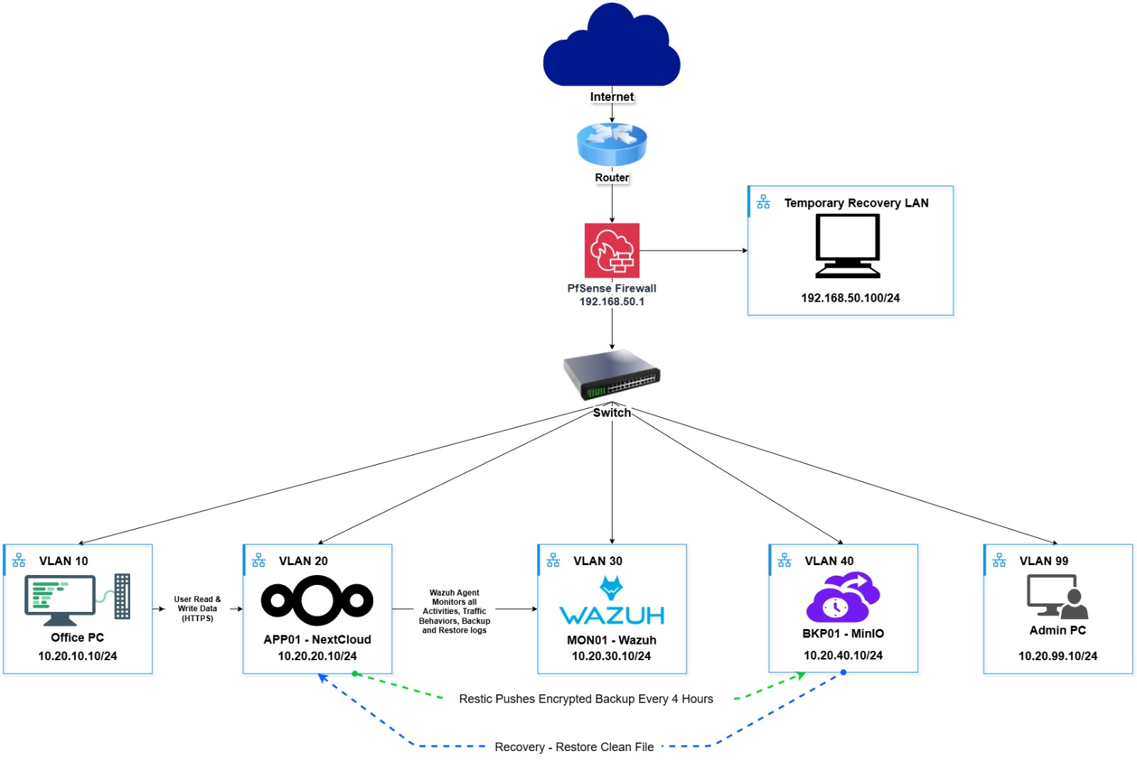
Figure 1. Project prototype segmentation model. Product names in this figure represent the prototype implementation, not mandatory production products.

6 Access Control Design
There is access control in multiple locations as the firewall can't decide which Finance or Sales file a user should be accessing. The firewall is responsible for regulating communication between systems. The application then checks the user account and role before giving access to the data. The administration and logging remains separate controls too.
Layer | Question | How AG-3 uses it
Identity | Who is the user or service? | Individual accounts, privileged accounts and service credentials identify who is requesting access.
Role / application | What information should the subject use? | Business roles and application groups control which data a user can use.
Network | Which systems can communicate? | The firewall controls which systems can communicate between zones.
Privileged access | Who can administer the systems? | Administrative roles are separated so normal users do not receive firewall, monitoring or backup administration.
Monitoring | Can important access be reviewed later? | Firewall, application, monitoring and backup logs provide evidence where supported.

This implies that, when configured to use HTTPS to reach APP01, a user will not automatically have access to all the folders. The user can still read or change what the application role allows, although the connection is allowed by the firewall. This is why AG-3 uses network filtering together with role-based access control (Sandhu et al. 1996).

7 Identity, Roles and Authentication

7.1 Business and technical role model
The role model begins by the work a person has to do. Users of Finance should be given access to Finance Data, Users of Operations should be given access to Operations Data and Normal Staff should be given access to the shared company information. Also technical roles are separated, whereby IT Support is not automatically given access to administration of the firewall, monitoring or backup.
Role | Main responsibility | Access principle
Management | Business oversight and approved reporting. | Business information as required, but no routine infrastructure administration.
Finance | Invoices, payments and financial records. | Finance data and shared business information only.
Operations | Livestock, crop and operational records. | Operations data and shared information only.
Sales and Customer Service | Customer, sales and order records. | Sales data and shared information only.
General Staff | Normal shared company information. | No department or administrative access unless approved.
IT Support | User/device troubleshooting, approved application support and routine technical assistance. | Limited technical access only. IT Support does not automatically receive firewall administration, Linux root, SIEM administration, backup administration or unrestricted business-data access. Escalation is required when higher privilege is needed.
Security Administrator | Monitoring, alert review and security-system administration. | Security monitoring and approved physical-security systems. No backup administration by default.
Backup Administrator | Backup repository, retention and recovery. | Backup systems only. No firewall administration by default.
System Administrator | Firewall, servers and infrastructure administration. | Privileged infrastructure access required for system duties, but not automatic ownership of business data.
Guest - optional | Visitor internet use. | Internet only and no internal business access.

7.2 Authentication and account rules
Normal users should be targeted to use individual accounts to enable the important actions to be traced back to a person. Normal staff should not use the same account for browsing and administration; use a separate admin account. Important and privileged access must be protected by MFA, if this feature is available in the selected platform. The prototype has been tested for TOTP with the main administrator account of Nextcloud (Nextcloud GmbH 2026).
Service accounts are not typical user accounts. They should only be shared with the service they support, and not for day to day interactive work. This is particularly relevant for the backup process as APP01 has to use a different credential to transfer the backup data to BKP01.

8 Application Role-Based Access Control
The business application must be given group based permissions, so that users get only the folders and functions they need to perform their job. In the prototype the control is done using Nextcloud. Nextcloud or other appropriate platform is used for the target design as long as the same role separation is kept.

8.1 Prototype Nextcloud groups and target role mapping
The prototype group names listed below are included verbatim as in the prototype development as it is necessary to match the screenshots and evidence within the document. The group name 'Fianace' has the spelling from the prototype. This should be fixed to 'Finance' in a controlled change of the prototype evidence for a production deployment.
Prototype group | Target business purpose | Resource / scope | Designed permission
All-staff | All normal employees | Shared company information | Read or approved collaboration access.
Management | Management team | Management folder; selected department information | Read/Write to Management; read-only oversight where approved.
Fianace | Finance department | Finance folder | Read/Create/Modify/Delete within Finance data according to role.
Operations | Operations department | Operations folder | Read/Create/Modify/Delete within Operations data according to role.
Sales | Sales and Customer Service | Sales folder | Read/Create/Modify/Delete within Sales data according to role.
IT | IT technical staff | IT resources | Technical collaboration access only; this group does not automatically grant infrastructure administration.
Reviewers | Approved reviewers | Selected shared information | Read-only review access.
Backup | Backup-related application role | Backup-related application scope | Restricted service/backup-related application access only.
Project-Users | Prototype project users | Prototype shared project area | Prototype-only shared access used for demonstration/testing.
The key is that access to APP01 is not the same as folder access. The firewall can grant access to HTTPS on APP01 but it is a decision of the Nextcloud group which folder the user can read, create, modify or delete. This maintains network access and access to business data as two distinct controls.

8.2 Role-based access matrix
Role | General files | Department data | Application administration | Security monitoring | Backup | Firewall
Management | Read/Write | Approved management information only | No | View approved security reports only; no platform administration | No backup repository or console access | No
Finance | Read | Finance Read/Write | No | No | No | No
Operations | Read | Operations Read/Write | No | No | No | No
Sales | Read | Sales Read/Write | No | No | No | No
General Staff | Read | No unless approved | No | No | No | No
IT Support | Read/Write to IT shared resources only | Temporary department access only for an approved support task | Troubleshoot application/user issues; no role or group administration | View service status/logs needed for support; no alert-rule administration | No repository administration; status only if assigned | No independent rule changes; supervised diagnostic access only
Security Administrator | No normal need | No | No | Security platform administration | No | View firewall logs only; no rule changes
Backup Administrator | No normal need | No | No | View backup-related monitoring status only | Backup repository, retention and recovery administration | No
System Administrator | Temporary access only when approved support requires it | Temporary department access only for approved support | Server/application maintenance; role and folder permissions changed only when authorised | Maintain MON01 platform; security investigation remains with Security Admin | Emergency repository access only when approved or Backup Admin is unavailable | Firewall administration
Infrastructure administration doesn't necessarily equal business data ownership. The system administrator might require technical access to maintain APP01, however access to Finance, Sales or Management information should be maintained as per business role and might require routine access. The use of higher access should only be permitted where the use of the support work has been approved.

9 Privileged Access Control
Administrator accounts are separated from other accounts in order to prevent changing of controls that protect the rest of the system. Providing full access to all technical users would ease the work, but would also magnify the losses should one technical user account get compromised. Therefore, the design tries to separate the system administration and security and backup administration where possible (Sandhu et al. 1996; Syed et al. 2022).
System capability | Normal user | IT Support | System Admin | Security Admin | Backup Admin
Firewall / gateway | Deny | View status and run supervised diagnostics only | Admin | View logs only | Deny
Business application server | Deny | Troubleshoot approved application/user issues; no root access | Admin | Read security logs when required | Deny
Application administration | Deny | No role/group changes; user support only | Application maintenance and approved admin changes | Deny | Deny
SIEM / monitoring platform | Deny | View service status/logs needed for support | Platform maintenance | Security administration | Deny
Backup platform | Deny | Deny | Emergency access only when approved | Deny | Backup administration
NVR / CCTV - target | Deny | Hardware/service troubleshooting only | Platform maintenance only | Security administration | Deny
RFID controller - target | Deny | Hardware/service troubleshooting only | Platform maintenance only | Security administration | Deny
Managed switch / AP - target | Deny | View status and perform approved troubleshooting | Network administration | View security logs/status only | Deny

The management VLAN 99 is the default VLAN to start infrastructure administration in the target design. Simply connecting to VLAN99 does not suffice. The workstation authorized by the administrator, privileged account still need to be consistent with the destination system and management service for access policy. Thus, network location is only a component of the access decision as opposed to a final decision (Rose et al. 2020).

10 Firewall Policy and Access Control Matrix

10.1 Address and gateway model
VLAN | Subnet | Gateway | Role
10 | 10.20.10.0/24 | 10.20.10.1 | Office
20 | 10.20.20.0/24 | 10.20.20.1 | Server
30 | 10.20.30.0/24 | 10.20.30.1 | Security
40 | 10.20.40.0/24 | 10.20.40.1 | Backup
99 | 10.20.99.0/24 | 10.20.99.1 | Management
50 optional | 10.20.50.0/24 | 10.20.50.1 | Guest

10.2 Firewall rule method
In the prototype, the firewall rules are based on the traffic that the systems require. pfSense inspects interface rules as traffic comes in to the firewall and processes them in order. These connections are allowed and the reply traffic will come back through the same state without requiring another broad reverse rule (Netgate 2026b). The order of the rules is significant.
- Specific mandatory service rules are set against more general rules on the same interface.
- Normal users are not able to reach sensitive internal destinations (Backup, Management, etc.) before Internet access is considered.
- Infrastructure services (DNS and NTP) may only be provided to authorized resolvers / time sources.
- Internet access for software update is restricted to systems and protocols that need it.
- An unapproved internal communication is blocked with a final deny-and-log rule.
- After major rule changes, existing states and logs should be checked during testing because old states can affect the observed result.

10.3 Firewall access control matrix
The protocol for agent communication is TCP 1514 and during agent enrolment is TCP 1515 for the prototype. Normal telemetry and enrolment, which do not aim for the same purpose, are kept as separate paths (Wazuh 2026).
Source | Destination | Service | Action | Reason
Office VLAN | Business application service | TCP 443 / approved HTTPS | Allow | Normal users need HTTPS access to the business application.
Office endpoint | Security monitoring platform | TCP 1514 where agent telemetry is used | Allow | Used only for endpoint security telemetry.
Office endpoint | Security monitoring platform | TCP 1515 during enrolment only | Allow when required | Used only when an endpoint is enrolled or re-enrolled.
Office VLAN | Backup VLAN | Any | Deny + log | Office users do not need direct access to the recovery storage.
Office VLAN | Management VLAN 99 | Any | Deny + log | Normal Office users do not need infrastructure administration.
Office VLAN | Internet | TCP 80/443 | Allow | Office users need approved Internet access for normal business use and updates.
Business application server | Backup repository | TCP 9000 in prototype / approved backup API in target design | Allow | APP01 pushes backup data to the BKP01 MinIO API.
Business application server | Security monitoring platform | TCP 1514 | Allow | APP01 sends security telemetry to MON01.
Business application server | Security monitoring platform | TCP 1515 when enrolling/re-enrolling | Allow when required | Used only when APP01 is enrolled or re-enrolled.
ADMIN-PC | Firewall management interface | TCP 443 or approved management protocol | Allow | Firewall administration starts from the approved management host.
ADMIN-PC | Business application server | TCP 22/443 where required | Allow | Approved server and application administration.
ADMIN-PC | Security monitoring platform | TCP 22/443 where required | Allow | Approved monitoring administration.
ADMIN-PC | Backup platform | TCP 22 and approved admin/API ports | Allow | Approved backup administration.
Internal systems | Approved DNS resolver | UDP/TCP 53 | Allow | Internal systems use an approved resolver for name resolution.
Internal systems | Approved NTP source | UDP 123 | Allow | Consistent time is required for authentication, backup and log correlation.
Approved servers | Internet update sources | TCP 80/443 as required | Allow | Approved servers need controlled access for operating-system and application updates.
Servers | Other unnecessary Internet destinations | Any | Deny unless justified | Servers should not have broad outbound access without a reason.
Optional Guest VLAN | Internet | DNS + approved web | Allow | Visitor Internet access only.
Optional Guest VLAN | All internal zones | Any | Deny + log | Guest devices are not allowed into the business networks.
Any zone | Unapproved internal destination | Any | Deny + log | Anything not approved stays blocked and is logged.

11 System-to-System Access Mapping
Approved system-to-system paths are kept small to prevent that one compromised system automatically gets access to other zones. Office network begins normal business connections, APP01 begins push backup to BKP01 and sends monitoring traffic to MON01 and ADMIN-PC begins approved administration connections from the Management network. All other paths should be kept closed except if there is an obvious need to open it.
Path | Normal direction | Purpose | Control
Office -> business application | Office initiates | Business data access | HTTPS only plus authenticated role/folder permissions.
Office endpoint -> monitoring | Endpoint initiates where an agent is deployed | Endpoint telemetry | Approved telemetry port only.
Business application server -> monitoring | Server initiates | Server monitoring | Approved agent/event path only.
Business application server -> backup | Server initiates | Push backup | Approved backup API plus dedicated service credentials.
BKP01 -> MON01 | Backup initiates | Backup telemetry (Wazuh agent) | Approved TCP 1514/1515 only.
ADMIN-PC -> infrastructure | Management initiates | Administration | Only required management ports and privileged accounts.
Office -> Backup | Blocked | No business requirement | Firewall deny and log.
Office -> Management | Blocked | No business requirement | Firewall deny and log.
Backup -> Server | Blocked by default | Backup repository should not freely initiate connections into Server zone | Permit only an explicitly approved recovery/management path if required.
Guest -> Internal | Blocked | No business requirement | Firewall deny and log.

12 Backup Access Control
The Backup VLAN is not considered to be a shared storage VLAN; it is considered a recovery area. Our prototype has a push based backup. APP01 initiates the connection with the MinIO API running on BKP01 on port 9000 and sends the backup data via the connection. The backup path is only opened from the server side when it is needed (Group PG5 2026) and is not available for any normal Office User to access BKP01.
APP01 is the starting application of the backup, so it requires its own backup credential. This credential must only be used by the backup process, and should not be used as a normal user or administrator credential. By separating the backup credential from the regular Office accounts, an Office user will not be granted backup access merely by using the business application.
The prototype MinIO API indicates use of port 9000, and build evidence does not indicate the presence of a TLS certificate or the https configuration for the APP01 to BKP01 path. For this reason the artefact does not state that the prototype backup transport is encrypted. If this is a production deployment, the backup API should be TLS, thus protecting data as it is transferred between the Server and Backup zones.
Subject | Backup access | Reason
Business application backup process | Permitted through the approved backup API using a dedicated service identity. | Required backup path.
Normal employees | Denied | No business need and user endpoints have higher ransomware exposure.
Management users | No routine direct repository access | Management needs business reports/files, not backup administration.
Backup Administrator | Administrative access | Responsible for repository, retention and recovery.
System Administrator | Controlled/emergency access only where required | Prevents one administrator role from automatically controlling every recovery function.
Guest | Denied | No internal business access.

13 Monitoring and Logging
Access control is more effective if the team can also view what happened. That is why the target design stores firewall decisions, login events, privileged activities, security events and backup operations all in a log that can be examined later. In the prototype, the monitoring platform used is Wazuh, but the requirement is the monitoring not a particular product.
Activity | Target evidence source | Why it matters
Business application login / failed login | Application audit/security logs and central monitoring where integrated | Shows authentication attempts and supports investigation.
Firewall allow / deny | Firewall logs / central log platform | Shows whether the network policy made the expected decision.
Privileged system login | Operating-system/platform logs and central monitoring | Supports accountability for administrative access.
Backup operation | Backup client/repository logs and job status | Shows whether backup jobs and repository access succeed.
CCTV administration - target | NVR/platform audit logs | Provides accountability for viewing or changing surveillance systems.
RFID door event - target | Access-controller logs | Provides evidence of physical access to restricted areas.
Account or permission change | Application/system audit logs | Shows when access rights were added, changed or removed.
In the prototype, the communication and enrolment of the Wazuh agent should be represented as individual paths. The final piece of evidence should include the agents of the systems and one example event, its source and time. This should remain as an unfinished integration, not a completed integration, if pfSense firewall logs are not successfully received by MON01 prior to submission.

14 Physical Security and Optional Guest Access

14.1 CCTV, RFID and server-room access
The CCTV, RFID readers, the NVR and the access controller are not essential prototype requirements, but are target components for head office. Camera settings, deletion of recordings, and modification of door permissions in the normal Office user should not be possible. Security Administrators should be provided with the necessary technical access, and Management should be granted approved reports or viewing access, but not unrestricted administration access.
Technical staff should also be limited in access to the server and communications room. Physical access events should be recorded as they may provide an explanation as to what happened when a cyber event occurs at or around the same time as a physical event.

14.2 Optional Guest VLAN 50
Guest VLAN 50 is an optional extra and not one of the five VLANs which are core AG-3. When deployed, the internet is the only service that is allowed on the visitor devices on the network, and Office, Server, Security, Backup and Management networks are blocked.

15 Joiner, Mover, Leaver and Access Review
Access control doesn't end once an account has been setup. Someone may leave the company, transfer to another position or even move to a new one, and the permissions must go with them. Groups make this easier since the access can be changed by changing the role the user is a member of rather than each permission individually (Sandhu et al. 1996).
Stage | AG-3 process
Joiner | Create an individual account -> confirm role -> add required groups -> register MFA where required -> grant only approved resources.
Mover | Remove old role/group access -> assign the new role -> review inherited access -> verify that old sensitive access is no longer present.
Leaver | Disable the account promptly -> revoke active sessions/tokens -> remove groups and privileged access -> retain business data according to policy.
A quarterly access review is employed as a practical suggestion for this small-business design. Review of privileged accounts, firewall rules, service accounts and backup administration should also be conducted following major staff changes or system changes. If there is no clear owner or business purpose for access, access should be removed.

16 Emergency Access
A protected emergency or break-glass administrator account can be maintained for use in cases where administrative access is not available. It shouldn't be used for everyday use. The credential should be kept elsewhere, it should be documented when it was used, and a reason should be provided for the use, and the password/access method should be reviewed after the emergency use.

17 Acceptance Tests and Verification
The important controls must be evidenced in the final artefact. This involves testing the “should work” paths, as well as the “should not work” paths. The original acceptance matrix is kept to ensure that the full design can be traced and the prototype firewall matrix below shows the tests that were run on APP01, MON01 and BKP01. Untested controls are not reported as passed, but continue to appear as TO COMPLETE.

17.1 Firewall acceptance matrix
Test | Source | Destination / service | Expected | Reason
FW-01 | Office client | Business application HTTPS | PASS | Normal business access
FW-02 | Office client | Backup service/API | BLOCK | Office cannot reach backup repository
FW-03 | Office client | Management VLAN 99 | BLOCK | Normal users cannot reach administration
FW-04 | Office endpoint | Monitoring TCP 1514 | PASS if agent deployed | Approved telemetry path
FW-05 | Office endpoint | Monitoring TCP 1515 | PASS only when enrolment required | Approved enrolment path
FW-06 | APP01 | BKP01 prototype TCP 9000 | PASS | Validate push backup path
FW-07 | APP01 | MON01 prototype TCP 1514 | PASS | Validate server telemetry path
FW-08 | Office client | Firewall management TCP 443 | BLOCK | Users cannot manage firewall
FW-09 | ADMIN-PC | Firewall management TCP 443 | PASS | Approved management path
FW-10 | ADMIN-PC | APP01 TCP 22/443 | PASS | Approved server/application administration
FW-11 | ADMIN-PC | MON01 TCP 22/443 | PASS | Approved monitoring administration
FW-12 | ADMIN-PC | BKP01 admin/API ports | PASS | Approved backup administration
FW-13 | BKP01 / Backup zone | APP01 / Server zone unsolicited connection | BLOCK | Backup zone should not freely initiate traffic into Server zone
FW-14 | Internal host | Approved DNS resolver UDP/TCP 53 | PASS | Required name resolution
FW-15 | Internal host | Approved NTP source UDP 123 | PASS | Required time synchronisation

17.1.1 Executed prototype firewall test matrix
The table below shows the 15 firewall tests carried out on the three active prototype systems. Expected service paths to connect required service and unapproved service paths to time out. For the screen shot refer to Appendix A.
Test | Source | Destination / service | Expected | Observed result | Outcome | Evidence
FT-01 | APP01 10.20.20.10 | MON01 10.20.30.10 TCP 1514 | ALLOW | Connection succeeded | PASS | Figure A1
FT-02 | APP01 10.20.20.10 | MON01 10.20.30.10 TCP 1515 | ALLOW | Connection succeeded | PASS | Figure A2
FT-03 | APP01 10.20.20.10 | BKP01 10.20.40.10 TCP 9000 | ALLOW | Connection succeeded | PASS | Figure A3
FT-04 | BKP01 10.20.40.10 | MON01 10.20.30.10 TCP 1514 | ALLOW | Connection succeeded | PASS | Figure A4
FT-05 | BKP01 10.20.40.10 | MON01 10.20.30.10 TCP 1515 | ALLOW | Connection succeeded | PASS | Figure A5
FT-06 | APP01 10.20.20.10 | BKP01 10.20.40.10 TCP 22 | BLOCK | Connection timed out | PASS | Figure A6
FT-07 | MON01 10.20.30.10 | BKP01 10.20.40.10 TCP 9000 | BLOCK | Connection timed out | PASS | Figure A7
FT-08 | BKP01 10.20.40.10 | APP01 10.20.20.10 TCP 443 | BLOCK | Connection timed out | PASS | Figure A8
FT-09 | MON01 10.20.30.10 | APP01 10.20.20.10 TCP 22 | BLOCK | Connection timed out | PASS | Figure A9
FT-10 | MON01 10.20.30.10 | BKP01 10.20.40.10 TCP 22 | BLOCK | Connection timed out | PASS | Figure A10
FT-11 | BKP01 10.20.40.10 | MON01 10.20.30.10 TCP 22 | BLOCK | Connection timed out | PASS | Figure A11
FT-12 | BKP01 10.20.40.10 | APP01 10.20.20.10 TCP 22 | BLOCK | Connection timed out | PASS | Figure A12
FT-13 | APP01 10.20.20.10 | BKP01 10.20.40.10 TCP 9001 | BLOCK | Connection timed out | PASS | Figure A13
FT-14 | APP01 10.20.20.10 | MON01 10.20.30.10 TCP 22 | BLOCK | Connection timed out | PASS | Figure A14
FT-15 | MON01 10.20.30.10 | APP01 10.20.20.10 TCP 443 | BLOCK | Connection timed out | PASS | Figure A15
Result summary: 15 out of 15 prototype firewall tests were performed and the expected result was obtained. 10 unnecessary service paths were blocked and 5 necessary Wazuh/MinIO service paths were allowed. These results only apply to the APP01, MON01 and BKP01 flows tested; they are not a substitute for the unexecuted Office, Management, DNS or NTP acceptance tests above.

17.2 Access-control tests
Test | Control | Expected evidence
AC-01 | Finance user opens Finance folder | Finance account can read/write Finance data but cannot gain Backup or firewall administration.
AC-02 | Finance user attempts Sales/Operations restricted data | Access denied or not presented according to the configured role permissions.
AC-03 | Sales user opens Sales folder and attempts Finance folder | Own department access succeeds; Finance access is blocked.
AC-04 | Operations user opens Operations folder and attempts Finance/Sales restricted data | Own department access succeeds; unrelated department access is blocked.
AC-05 | General Staff account | Shared information is available but restricted department folders are blocked.
AC-06 | Management folder permissions | Management receives only the permissions documented in the final role design.
AC-07 | Nextcloud administrator MFA in prototype | TOTP challenge is required and successful login is recorded.
AC-08 | Normal user attempts monitoring administration | No administrative access.
AC-09 | Normal user attempts backup administration | No administrative access.
AC-10 | APP01 backup service identity | Backup succeeds through the dedicated path without backup-console administrative rights.
AC-11 | Leaver simulation | Test account is disabled and can no longer authenticate.
AC-12 | Privilege review | Privileged accounts and group memberships match the approved matrix.
AC-13 | Logging | At least one controlled access or deny event is visible with source and timestamp in the expected log location.

17.2.1 Executed prototype access-control evidence
The results from the following tests document the evidence collected in the Nextcloud prototype concerning access-control. The evidence indicates that each different user is getting different folders as per their role, a Finance user will not have direct access to Sales data and administrator login needs a TOTP second factor. Appendix C contains the screenshots referred to.
Test | Control | Expected | Observed result | Outcome | Evidence
AC-E01 | Finance officer - Finance folder | ALLOW / Read-Write | Finance folder opened and Test File.md is visible after the Finance user created it. | PASS | Figure C3
AC-E02 | Finance officer - Sales folder direct access | BLOCK | Direct attempt to open the Sales folder returned "Folder not found". | PASS | Figure C4
AC-E03 | Manager - approved business folders | ALLOW | Manager account shows Company Shared, Finance, Management, Operations and Sales folders. | PASS | Figure C1
AC-E04 | Foysal prototype account - role-specific folders | ALLOW / restricted by role | IT and Backup folder is visible with Company Shared, while Finance, Management, Operations and Sales are not shown. | PASS | Figure C2
AC-E05 | Nextcloud administrator - MFA | TOTP REQUIRED | After password authentication, Nextcloud requires a TOTP authentication code before login can continue. | PASS | Figure C5
Result Summary: 5 of 5 executed access-control evidence checks returned the expected result. The Finance positive and negative tests show how folders are separated by department, the Manager and Foysal screenshots show how the user can only see folders related to their role, and the TOTP challenge shows how MFA is implemented on the prototype administrator login.

17.3 Verification method
1. Before assuming the firewall is the problem, verify the source address, subnet, gateway and interface/VLAN configuration.
2. Ensure that the service to which you are connecting is listening locally on the correct port number.
3. Execute approved connection and write application level result (not ping).
4. Perform a matching denied test from an unauthorized role and/or network and document the denial and log, if available.
5. Check the status of the firewall states after making significant changes to the rule set when there is an existing state that could impact the results.
6. Packet Capture when suspect of routing, tagging, MTU or asymmetric traffic.
7. Test access to applications using a variety of roles rather than only using an administrator.
8. Demonstrate network connectivity and credential access for backup.

18 Known Gaps and Residual Risks
- The target design is product neutral, the prototype evidence is based on pfSense, Nextcloud, Wazuh and MinIO/Restic.
- Prototype is based on the TP-Link LS108G Unmanaged Switch. It can show the project connectivity and pfSense firewall behaviour but it does not offer production switch-port VLAN enforcement.
- The main Nextcloud administrator account has been verified with MFA. Note: Do not claim Organisations-wide MFA, until the required accounts are configured and tested.
- Any components that are part of the expanded head-office, such as CCTV, RFID, NVR, the access controller and so on are target-design components unless final implementation evidence is added.
- The current design for the small-office is to merge monitoring and physical-security devices together in a single Security VLAN (30). These devices should be in a separate Physical Security/IoT VLAN in a larger production network.
- Prototype push-backup model – there is a backup credential on or near APP01. Using a separate non-admin backup credential minimizes this risk, but does not eliminate it.
- The prototype has one main firewall and other single points of failure. High availability is outside the core project scope.

19 Production Recommendations
- In the production network, use managed VLAN capable switches, allowing control of the VLAN membership at the switch ports (Netgate 2026c).
- Keep Management VLAN 99 reserved for strictly administration purposes and only approved administration devices and accounts.
- Implement a business application or collaboration platform that enables the required privileges for roles and MFA and audit logging. Nextcloud can be retained if it is required for the business, but is not essential.
- Have a central monitoring/SIEM platform capable of capturing and investigating the necessary security events. The monitoring capability is the fundamental requirement and Wazuh can be kept.
- Use a separate service credential for a protected backup platform with separate service credential, retention and tested restore capability. MinIO/Restic can be maintained, but it is not a requirement for the design.
- Where possible, enable MFA for privileged and critical business accounts (Ometov et al. 2018).
- When a lot of embedded devices and/or the risk level rises, separate Physical Security/IoT devices into their own VLAN from MON01.
- Back-up firewall configuration data, regularly audit firewall rules and purge rules where they do not have an obvious owner or business reason.
- Wherever possible, keep backups administration separate from normal system administration and periodically test restores.
- Look for high availability firewall and redundant switching and redundant Internet connection (if appropriate to the business impact and budget).

20 Conclusion
The AG-3 design explicitly partitions the five network elements and only exposes the necessary communication between the elements. The business application is accessible to the Office users, APP01 can send the push backup to BKP01, and the security events to MON01, and administration is initiated from the Management zone. The Back-up and Management access of the Office is still restricted by design. Using the available hardware, we have used pfSense, Nextcloud, Wazuh and MinIO/Restic for the prototype to build these controls. The five VLAN gateways and the main aliases are present in the saved pfSense configuration, and the access-control design divides between normal users, technical support, security administration and backup administration. But the prototype was also known to have some limitations, such as the unmanaged switch and the backup path APP01 to BKP01 was not verified as TLS. The prototype firewall evidence now includes an executed fifteen-test matrix, which includes required communication between Wazuh and MinIO as well as denied communication between APP01, MON01 and BKP01 for SSH and HTTPS and for MinIO-console. Acceptance tests of other items such as Office, Management, DNS, NTP and other tests have not been performed, but should not be reported as passed.

References
Mhaskar, N, Alabbad, M & Khedri, R 2021, 'A Formal Approach to Network Segmentation', Computers & Security, vol. 103, article 102162, doi:10.1016/j.cose.2020.102162.
Syed, NF, Shah, SW, Shaghaghi, A, Anwar, A, Baig, ZA & Doss, R 2022, ‘Zero Trust Architecture (ZTA): A Comprehensive Survey’, IEEE Access, vol. 10, pp. 57143–57179, doi:10.1109/ACCESS.2022.3174679.
Ometov, A, Bezzateev, S, Makitalo, N, Andreev, S, Mikkonen, T & Koucheryavy, Y 2018, 'Multi-Factor Authentication: A Survey', Cryptography, vol. 2, no. 1, article 1, doi:10.3390/cryptography2010001.
Sandhu, RS, Coyne, EJ, Feinstein, HL & Youman, CE 1996, 'Role-Based Access Control Models', Computer, vol. 29, no. 2, pp. 38-47, doi:10.1109/2.485845.
Group PG5 2026, AG-3 Cyber Resilience for an Agribusiness Back Office, project repository, GitHub, viewed 28 September 2026, <https://github.com/mahafuzfaysal2104/AG-3-Cyber-Resilience-for-an-Agribusiness-Back-Office-PG5>.
Netfilter Project 2026, Connection Tracking System, nftables wiki, viewed 28 September 2026, <https://wiki.nftables.org/wiki-nftables/index.php/Connection_Tracking_System>.
Netgate 2026a, Firewall Fundamentals, pfSense Documentation, viewed 28 September 2026, <https://docs.netgate.com/pfsense/en/latest/firewall/fundamentals.html>.
Netgate 2026b, Rule Methodology, pfSense Documentation, viewed 28 September 2026, <https://docs.netgate.com/pfsense/en/latest/firewall/rule-methodology.html>.
Netgate 2026c, Virtual LANs (VLANs), pfSense Documentation, viewed 28 September 2026, <https://docs.netgate.com/pfsense/en/latest/vlan/index.html>.
Nextcloud GmbH 2026, Two-factor authentication, Nextcloud Server Administration Manual, viewed 28 September 2026, <https://docs.nextcloud.com/server/stable/admin_manual/configuration_user/two_factor-auth.html>.
OPNsense 2026, Rules, OPNsense documentation, viewed 28 September 2026, <https://docs.opnsense.org/manual/firewall.html>.
Rose, S, Borchert, O, Mitchell, S & Connelly, S 2020, Zero Trust Architecture, NIST Special Publication 800-207, National Institute of Standards and Technology, viewed 28 September 2026, <https://doi.org/10.6028/NIST.SP.800-207>.
Scarfone, K & Hoffman, P 2009, Guidelines on Firewalls and Firewall Policy, NIST Special Publication 800-41 Revision 1, National Institute of Standards and Technology, viewed 28 September 2026, <https://doi.org/10.6028/NIST.SP.800-41r1>.
TP-Link 2026, LS108G 8-Port 10/100/1000Mbps Desktop Switch, TP-Link Australia, viewed 28 September 2026, <https://www.tp-link.com/au/business-networking/soho-switch-unmanaged/ls108g/>.
Wazuh 2026, Requirements - Wazuh agent enrollment, Wazuh documentation, viewed 28 September 2026, <https://documentation.wazuh.com/current/user-manual/agent/agent-enrollment/requirements.html>.

Appendix A - Firewall Test Evidence
The screenshots below provide the command-line evidence for FT-01 to FT-15 in the executed prototype firewall test matrix. Allowed tests show a successful TCP connection. Blocked tests show a timeout. The screenshots are kept in the appendix so the main body remains readable while the evidence remains traceable. (Evidence captured during prototype firewall verification on 29 September 2026.)
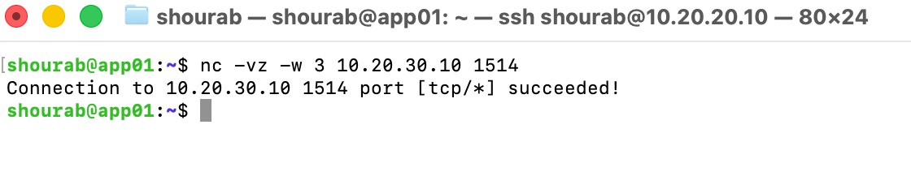
Figure A1. FT-01 - APP01 to MON01 TCP 1514 – allowed

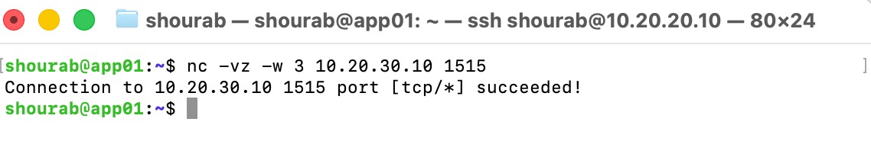
Figure A2. FT-02 - APP01 to MON01 TCP 1515 – allowed

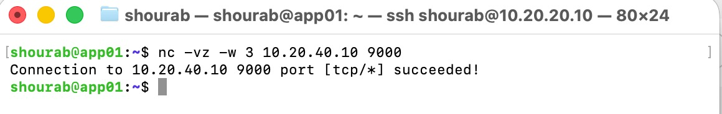
Figure A3. FT-03 - APP01 to BKP01 TCP 9000 - allowed

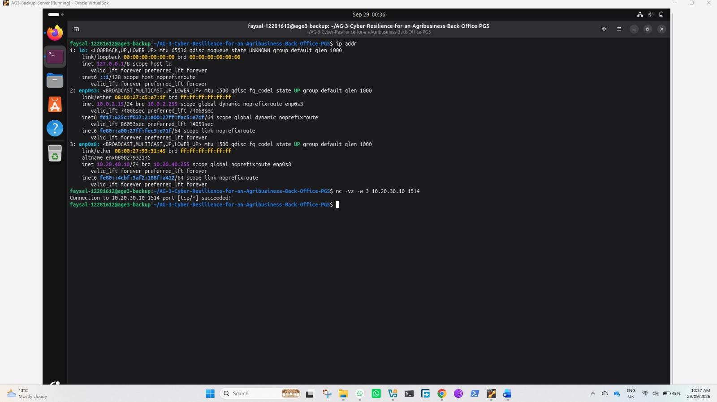
Figure A4. FT-04 - BKP01 to MON01 TCP 1514 – allowed

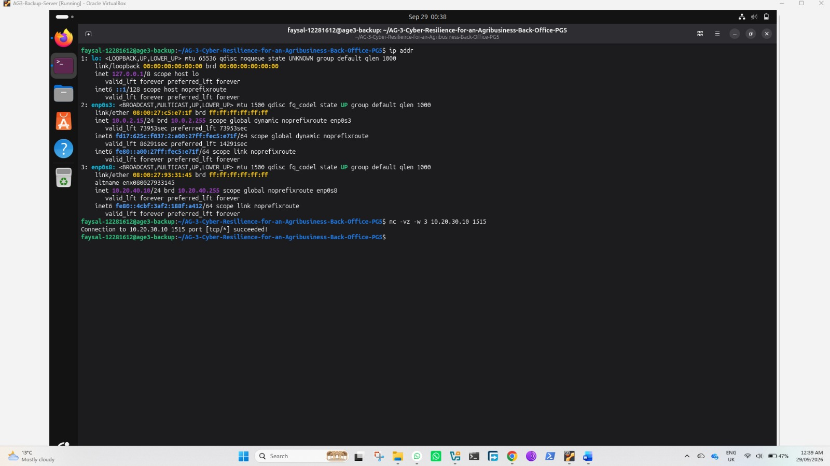
Figure A5. FT-05 - BKP01 to MON01 TCP 1515 - allowed

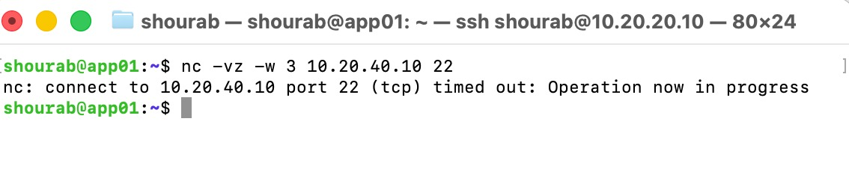
Figure A6. FT-06 - APP01 to BKP01 TCP 22 – blocked

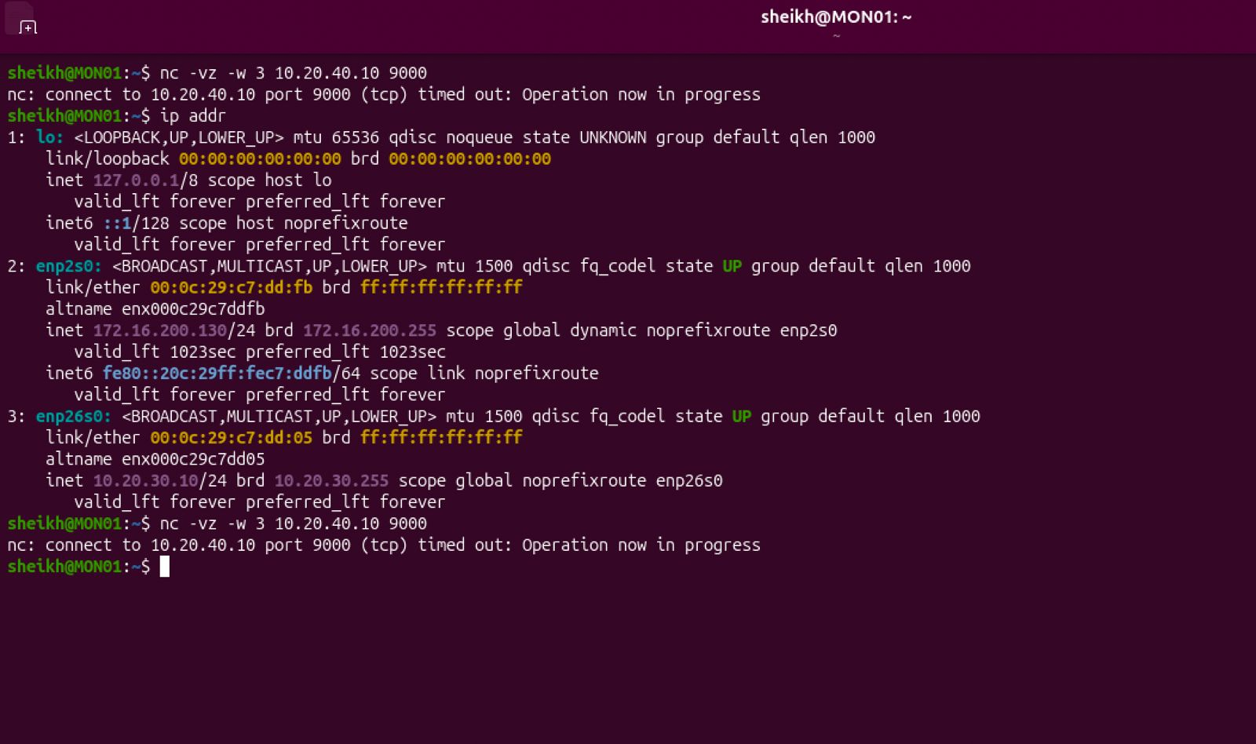
Figure A7. FT-07 - MON01 to BKP01 TCP 9000 – blocked

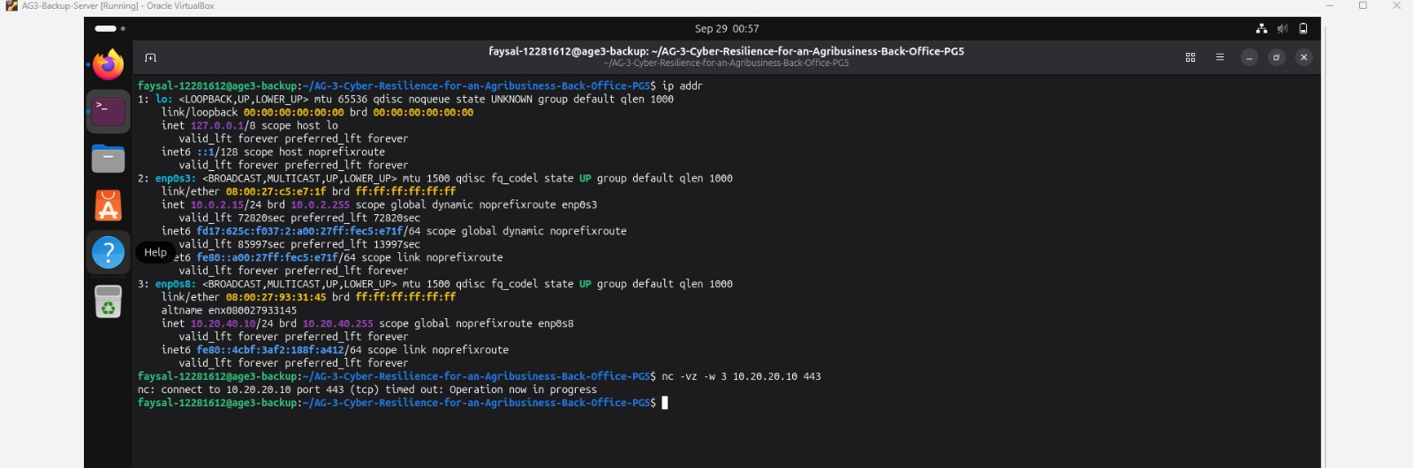
Figure A8. FT-08 - BKP01 to APP01 TCP 443 - blocked.
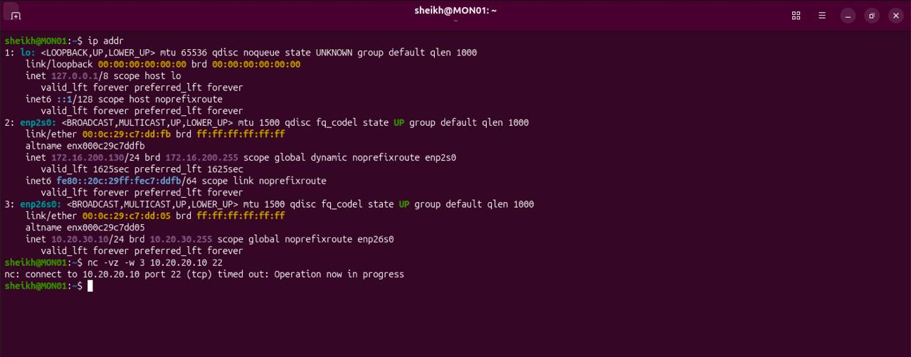
Figure A9. FT-09 - MON01 to APP01 TCP 22 – blocked

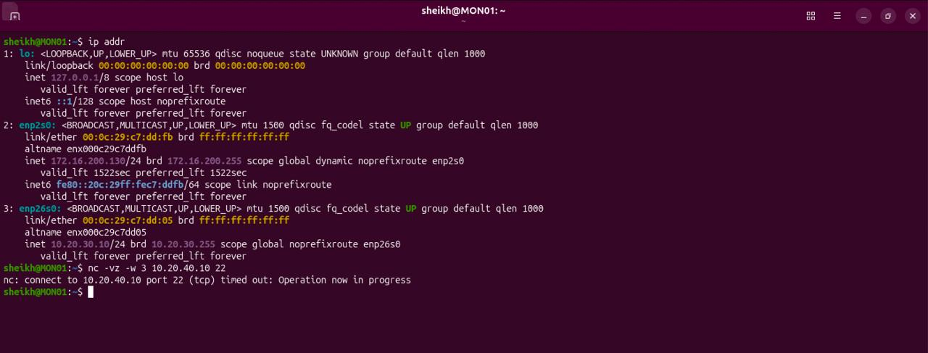
Figure A10. FT-10 - MON01 to BKP01 TCP 22 – blocked

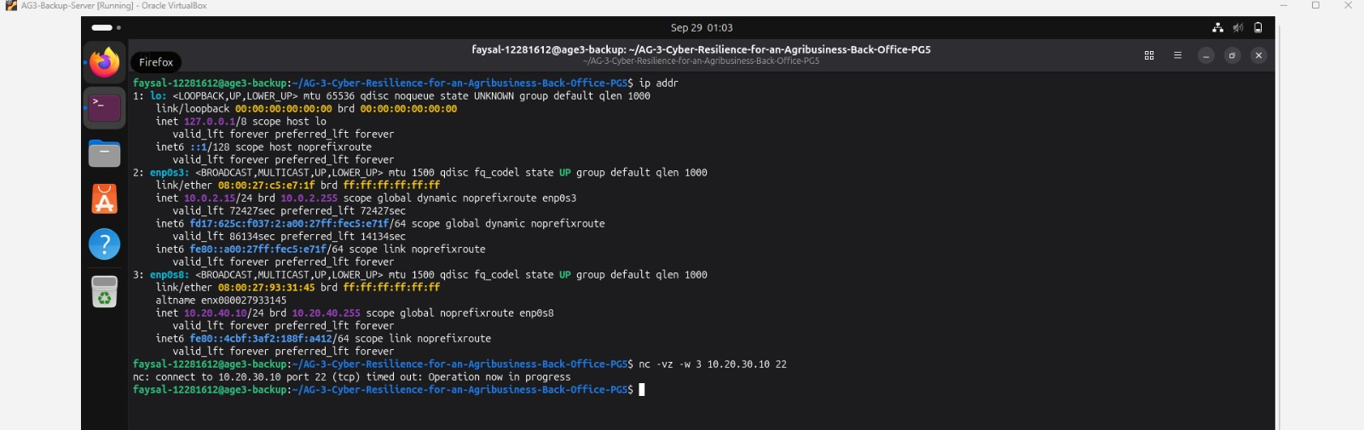
Figure A11. FT-11 - BKP01 to MON01 TCP 22 - blocked

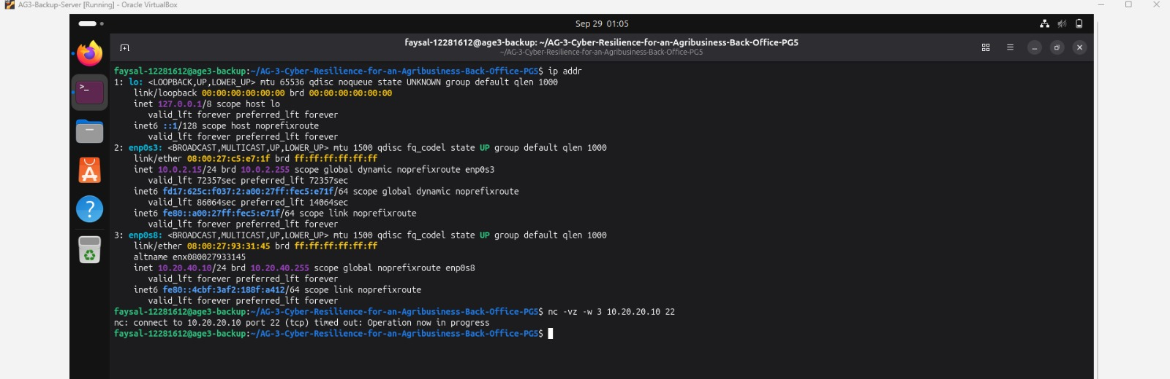
Figure A12. FT-12 - BKP01 to APP01 TCP 22 – blocked

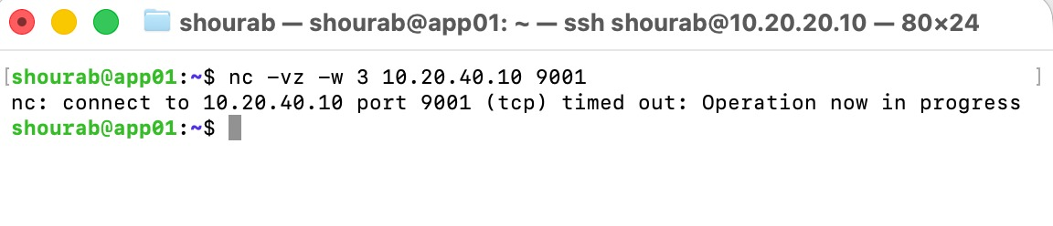
Figure A13. FT-13 - APP01 to BKP01 TCP 9001 – blocked

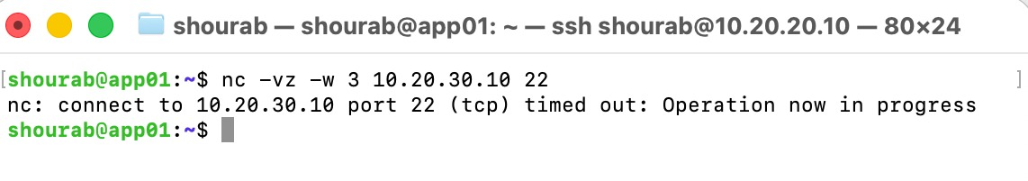
Figure A14. FT-14 - APP01 to MON01 TCP 22 - blocked

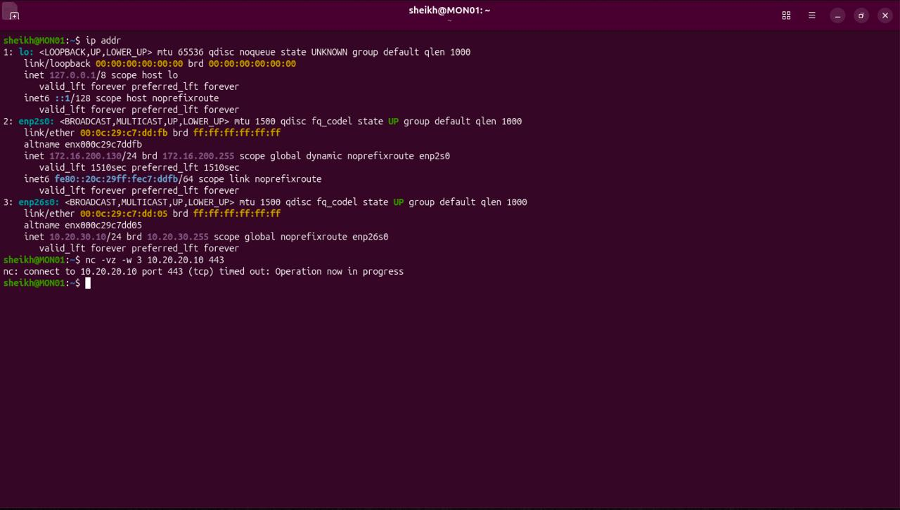
Figure A15. FT-15 - MON01 to APP01 TCP 443 - blocked

Appendix B - pfSense Configuration Evidence
The screenshots below show the pfSense VLAN and firewall rule configuration used in the prototype. They are included as configuration evidence to support the executed connectivity tests in Appendix A.
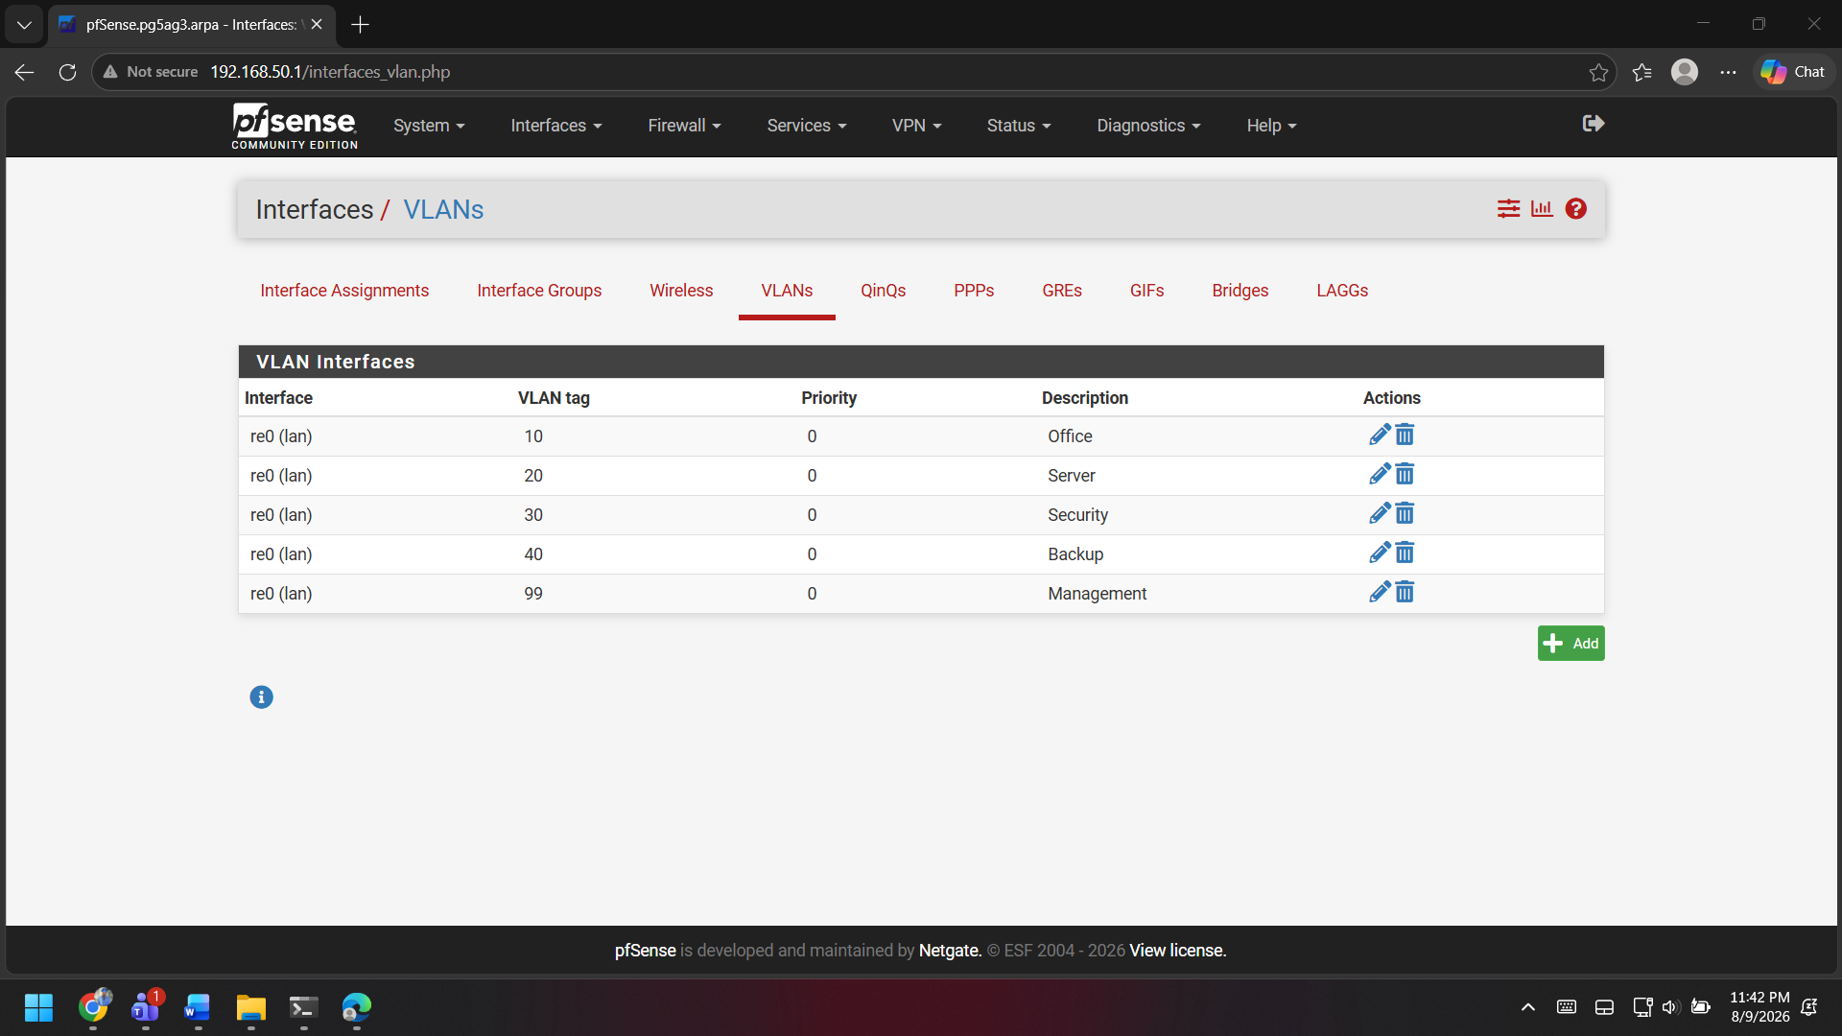
Figure B1. pfSense VLAN interfaces configured for Office, Server, Security, Backup and Management.

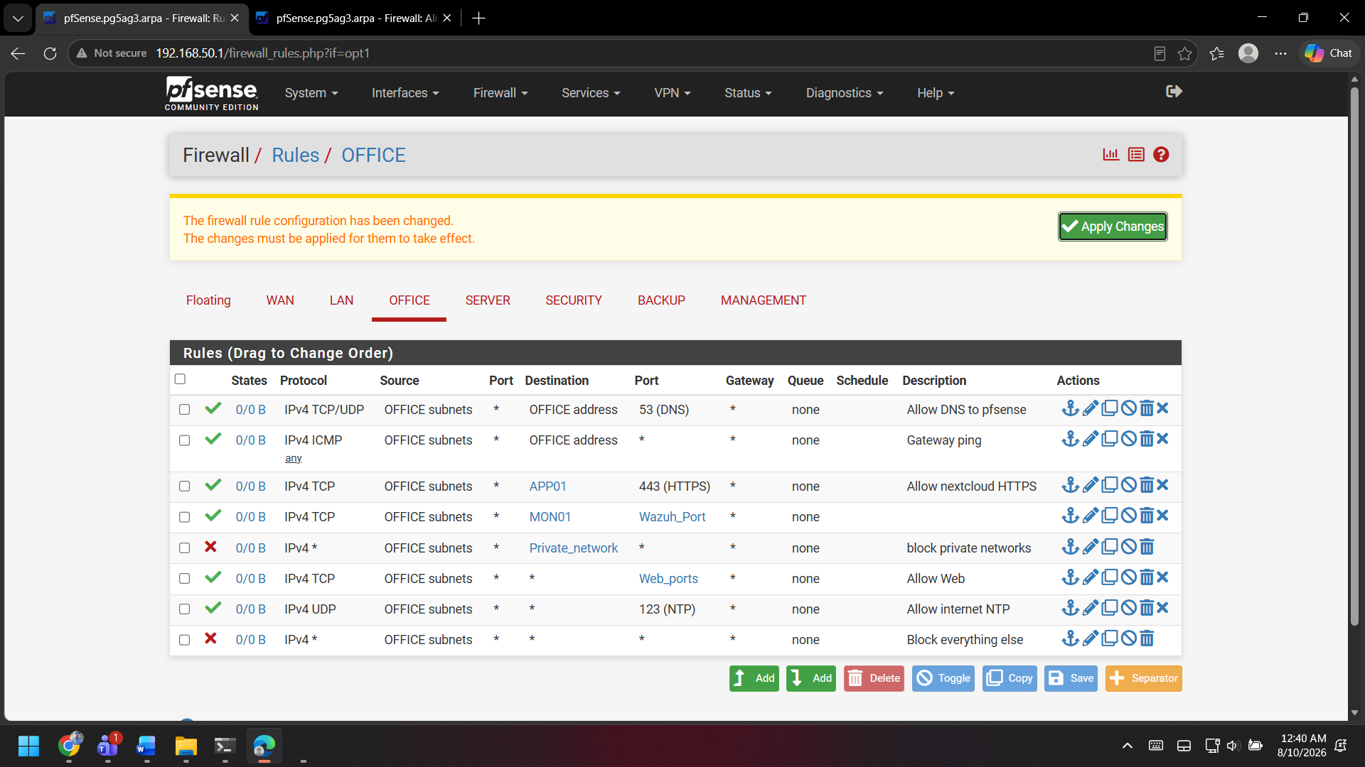
Figure B2. pfSense Office VLAN firewall rules used in the prototype.

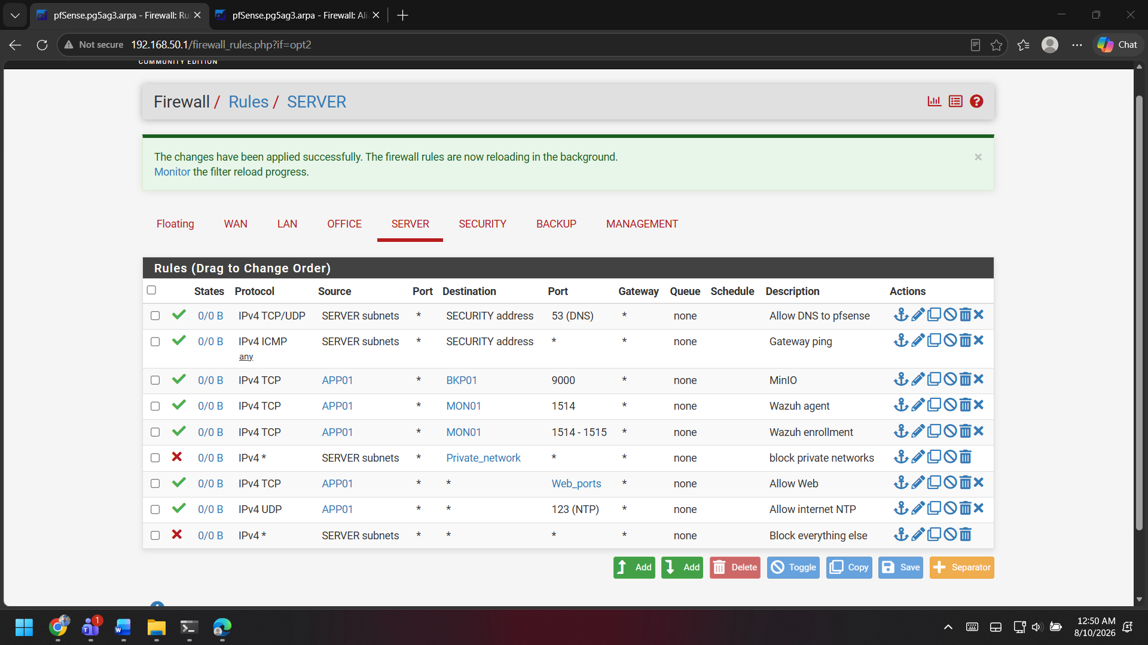
Figure B3. pfSense Server VLAN firewall rules showing the approved APP01 service paths.

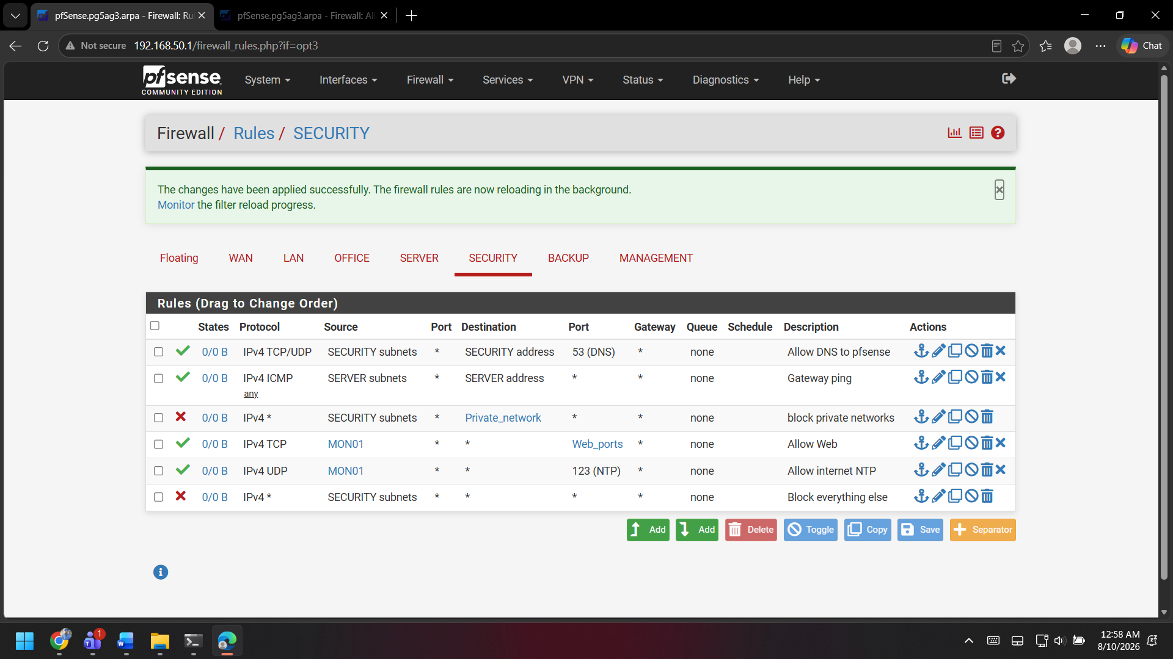
Figure B4. pfSense Security VLAN firewall rules used in the prototype.

Appendix C - Access Control Evidence
The screenshots below provide the application-level evidence for the executed access-control checks in Section 17.2.1. They show role-based folder visibility, successful Finance write access, denied cross-department access and the Nextcloud TOTP challenge. Evidence captured during prototype access-control verification on 29 September 2026.
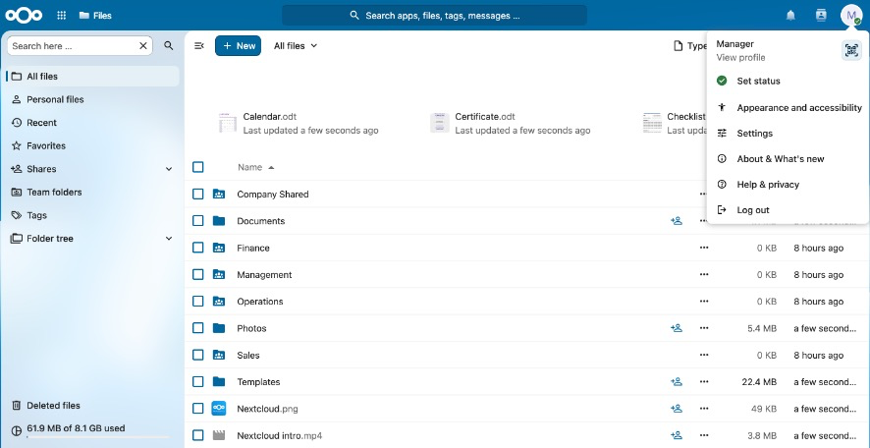
Figure C1. Manager account showing approved visibility of Company Shared, Finance, Management, Operations and Sales folders.
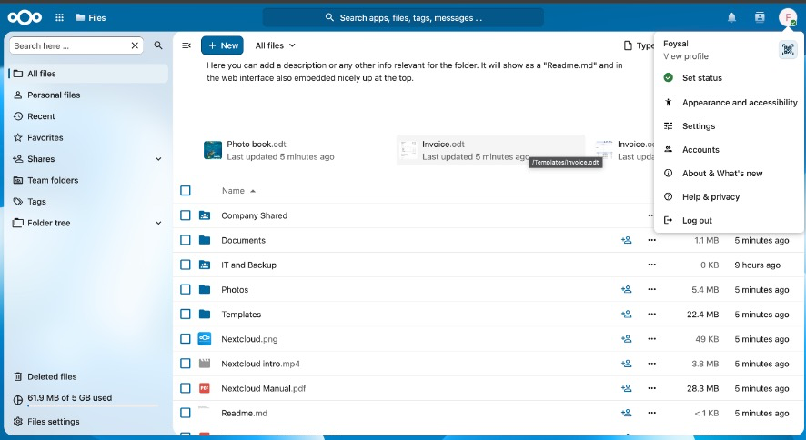
Figure C2. Foysal prototype account showing role-specific access to Company Shared and IT and Backup resources.
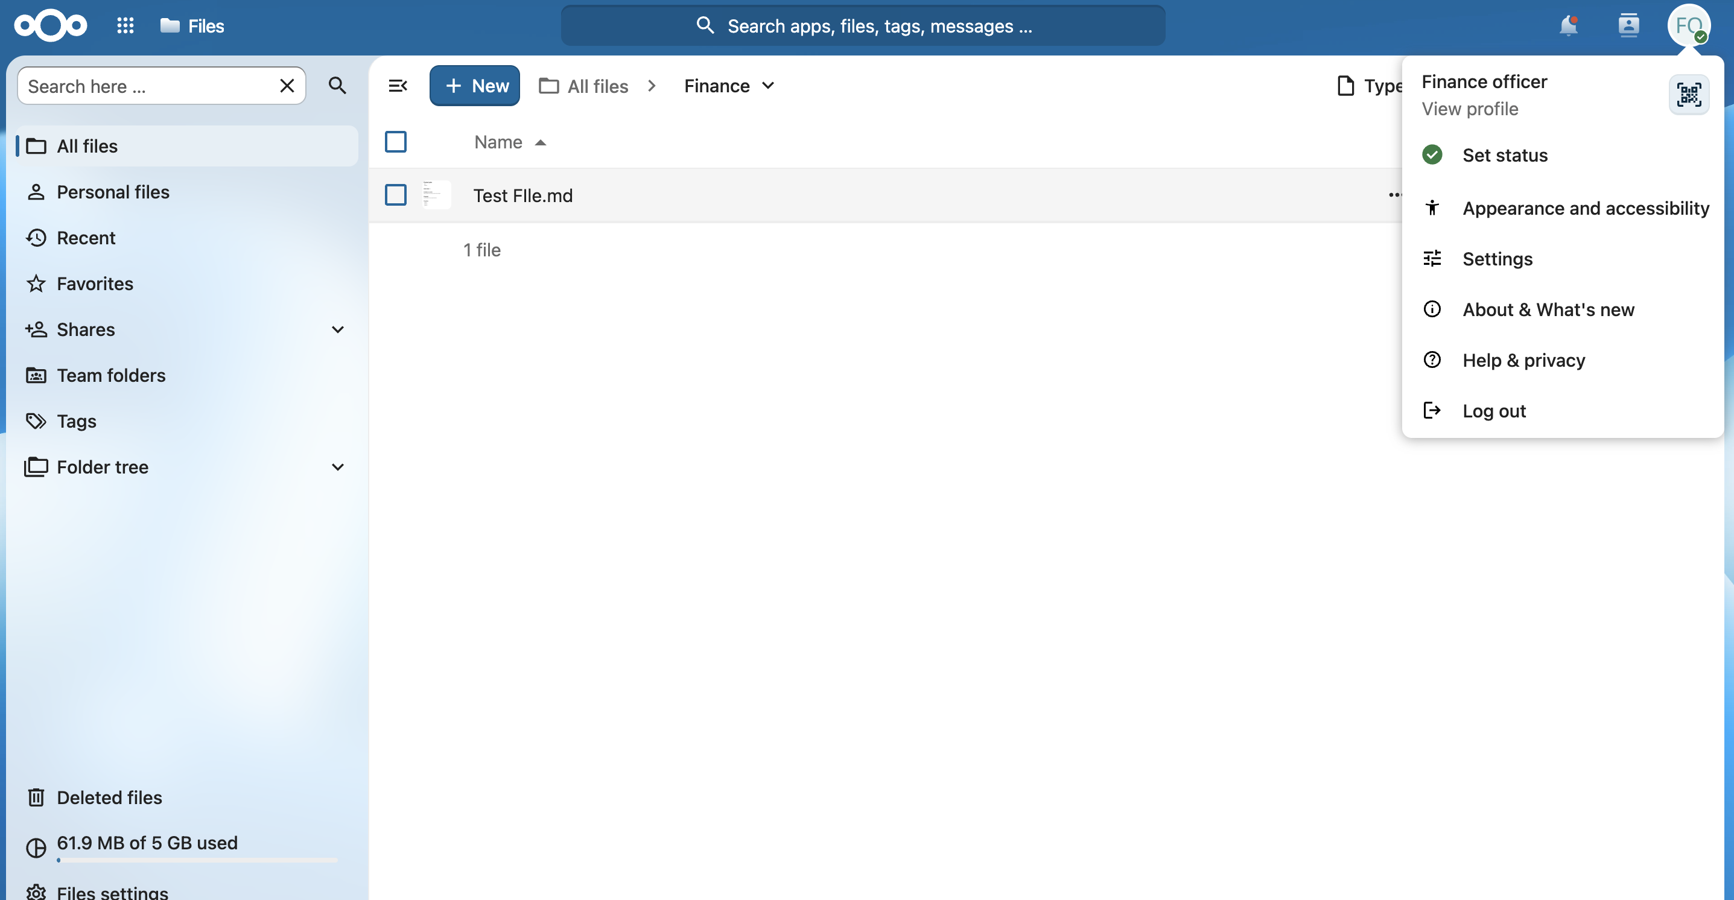
Figure C3. Finance officer inside the Finance folder with Test File.md, demonstrating successful Finance folder access and write capability.
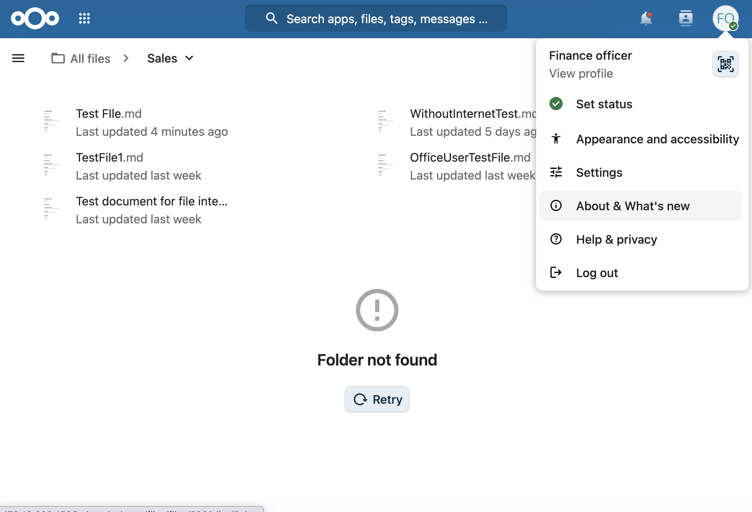
Figure C4. Finance officer direct attempt to open the Sales folder returning Folder not found, demonstrating cross-department access restriction.
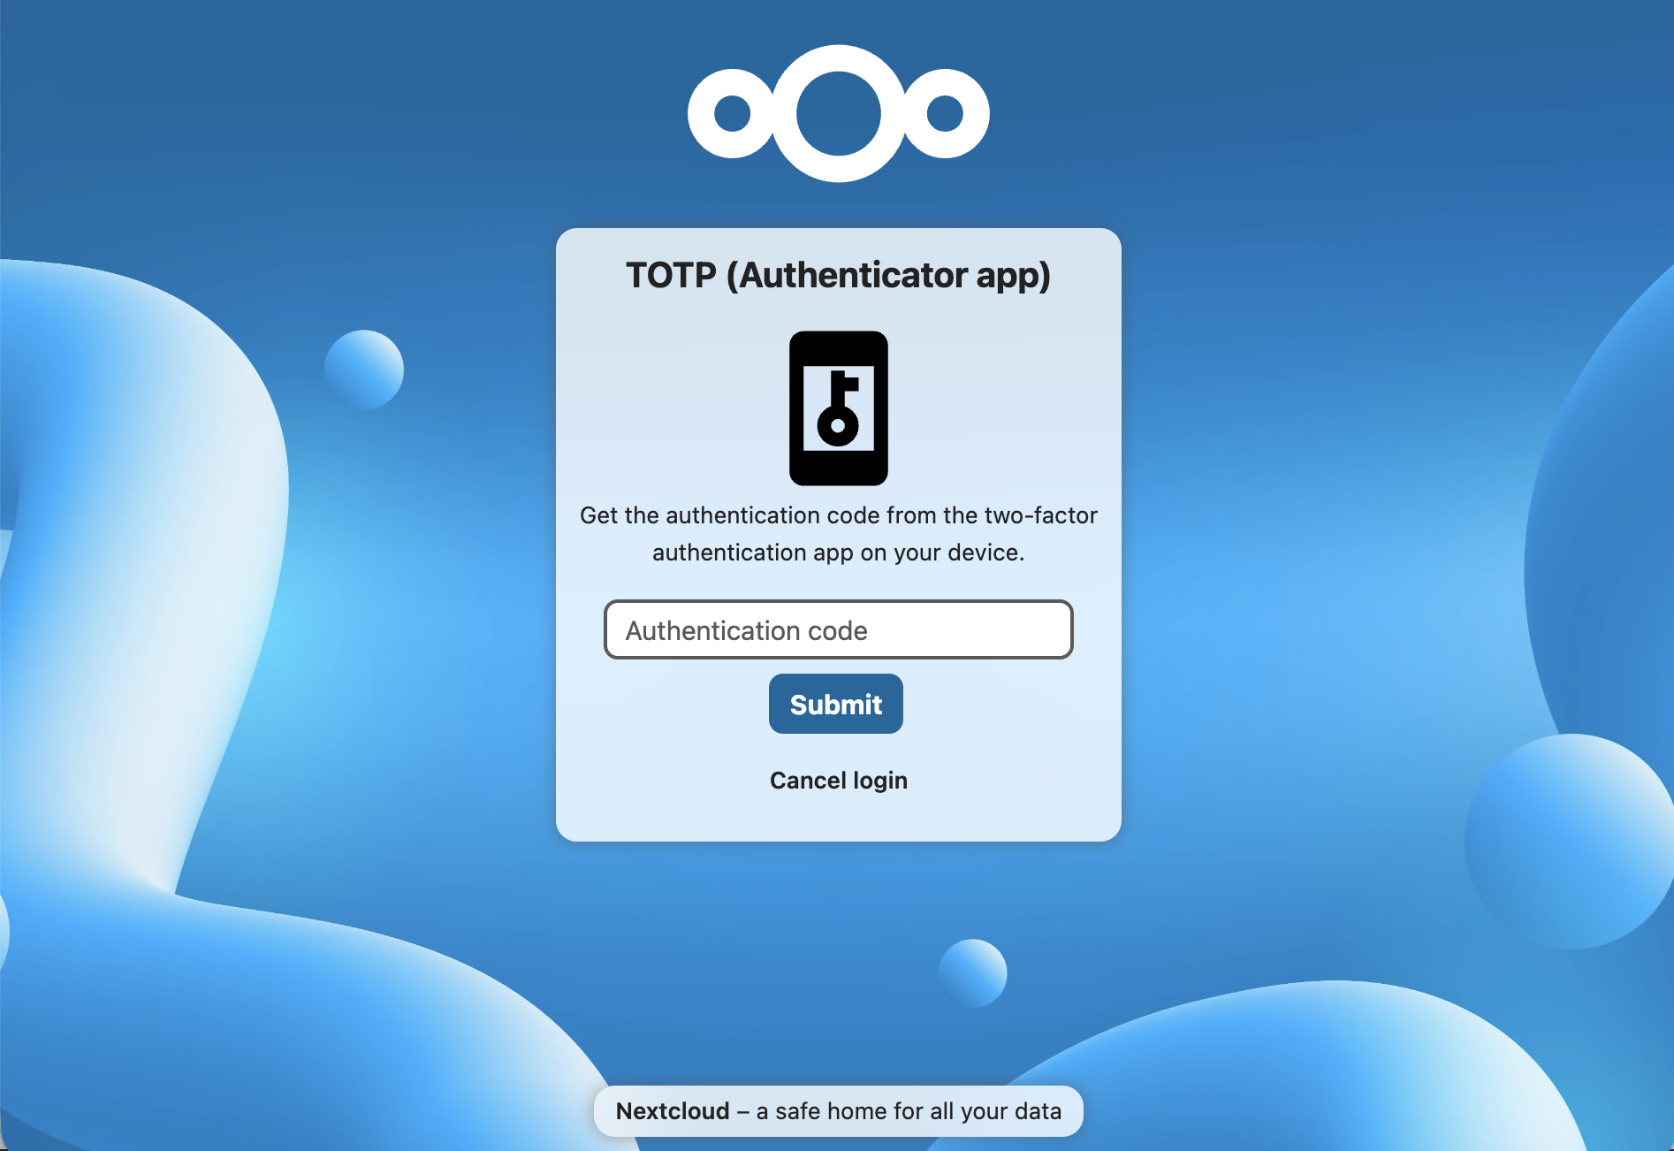
Figure C5. Nextcloud TOTP challenge displayed after administrator password authentication, demonstrating MFA enforcement on the prototype administrator login.

